Image | 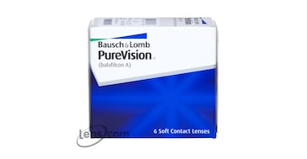
Brand | MICHEAL KORS
Model Name | BAUSH & LOMB PURE VISION
Price | RS 2499
PRODUCT DETAILS

